**EEE361**

**ASSIGNMENT**

**SET-4**

1. An Electric field in air (Z $≥$ 0) with the component:

E = 10 sin (⍵t + 3z) ax V/m hits normally in a river surface at z = 0 as shown in fig 1. below. Suppose that the river surface is smooth and the ε = 80ε0, µ = µ0 in river, Find

* + 1. ⍵
    2. The wavelength of the signal in air
    3. The reflected E and H field
    4. The transmitted E and H field

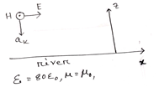

Fig: Problem 1

1. a. Explain the physical meaning of E = - $∇ V$.

To verify that E = yzax + xzay+ xyaz  V/m is truly an electric field, show that

b. $∇ × E = 0$

c. $\oint_{L}{E∙ⅆl}$ = 0, Where L is the edge of the square defined by 0 < x, y < 2, Z =1.

1. Given that F = x2yax – yay, Find

a. $\oint_{L}{F∙dl}$ where L is shown in figure below

b. $\oint_{L}{(∇× F)∙ dS}$ where S is the area bounded by L

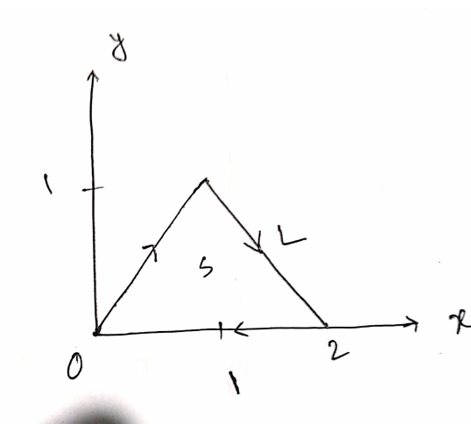

Fig: Problem 3

1. a) Given, = m sin(x) sin (t) y and = m/µo cos(x) cos (t) z. Determine whether these fields satisfy Maxwell’s equations or not.

b) Given that, in free space = m sin (wt-βz) y. Find $\overline{D}$, $\overline{B}, \overline{H}$ and d. Then show that $\overline{∇}.\left(\overline{∇}×\overline{H}\right)$ =0.

c) Identify weather these functions satisfy the wave equations or not. Show all the calculations.

1. $B = \frac{10}{ρ} cos (ωt - 2ρ) a_{∅}$ (This is Cylindrical co-ordinate [ u can use internet to know the calculation process])
$sinω (100z + 50t)$

2. If any EM field fails to satisfy Maxwell’s Equation and the wave equation derived from them, then that is said to be nonexistent or not Maxwellian. Suppose the following expressions exist in charge free-regions. Find weather they are Maxwellian or not? State why the expression/s are not Maxwellian. (Show Calculation)

$A = 40 sin (ωt + 10x) a_{z}$

$B = \frac{10}{ρ} cos (ωt - 2ρ) a_{∅}$

$C = ( 3 ρ^{2} cot ∅a_{p} + \frac{cos ∅}{ρ} a_{∅}) sin ωt$

$D = \frac{1}{r} sinθ sin(ωt - 5r) a_{∅}$